Exploring the emission spectrum of the hydrogen atom. Name: __________________________

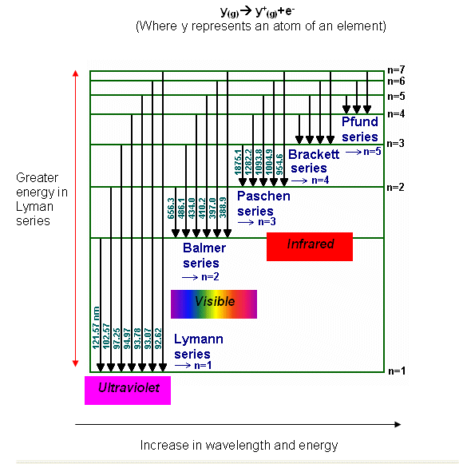

( )

1

*nf2*

1

*ni2*

-

Δ*E* = −*hcRH*

**n=8**

**n=7**

**n=6**

**n=5**

**n=4**

**n=3**

**n=2**

**n=1**

In the text, do p283 #1- 5

Show all your work for the following problems.

1. Show that –hcRH = – 2.18 x 10-18 J

2. Use the Rydberg equation to verify your choice of a) one wavelength for a transition in the Lymann series, b) one wavelength for a transition in the Balmer, and one wavelength for a transition in the Pachen series.

3. Determine the wavelengths for the 4 transitions of the Brackett series and the 3 transitions of the Pfund series. Label the diagram appropriately.